LAB TEST :01
Name : Shari punnisa
Batch no : 02
Hall ticket number : 2403A51038
Set : A
- Write a Python code to calculate the sum of odd and even numbers in a given list using GitHub Copilot along with VS Code. Use zero shot prompting

Prompt : Write a python program that calculate the sum of odd and even numbers in a given list and list as a user input form
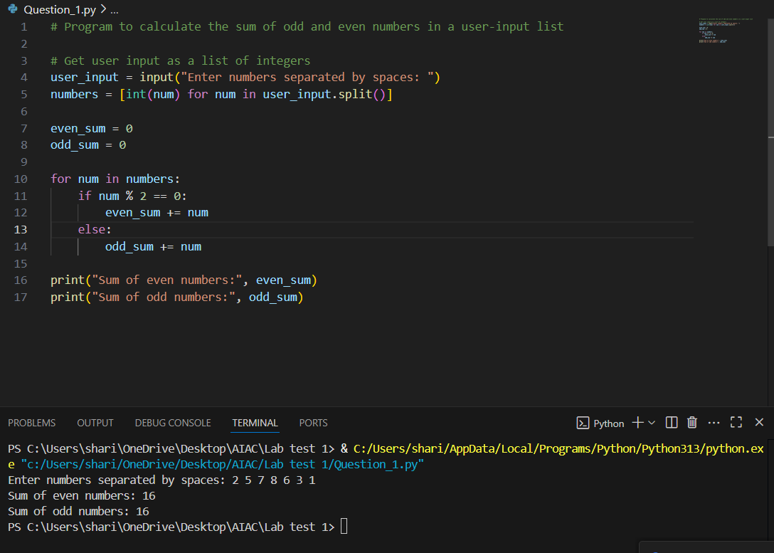

- Write a Python code for given a list of integers, remove duplicates and print the sorted result. GitHub Copilot along with VS Code. Use one shot prompting.
Prompt : Write a python program for given a list of integers , remove duplicates and print the sorted result , list as user input form . Example: list=[1,3,5,3,5,7,2],sorted_list=[1,2,3,5,7]
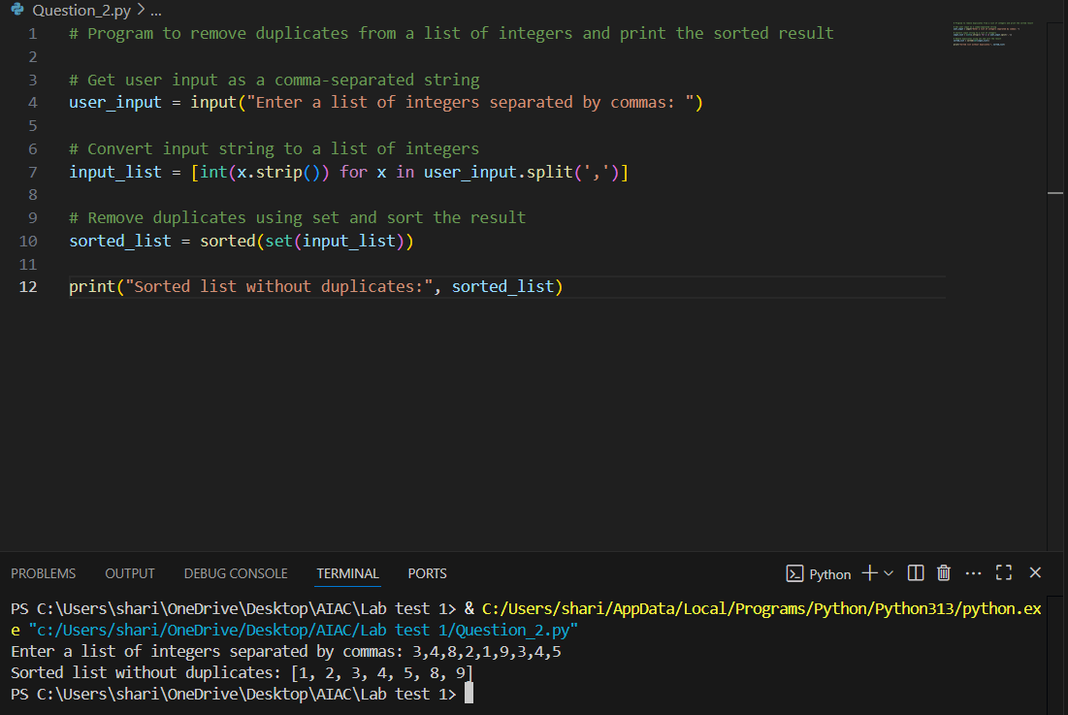

3. Write a Python function that converts the temperature between Celsius, Fahrenheit, and Kelvin based on user choice. Use the Cursor AI tool. Use few shot prompting.
Prompt : write a python function that converts the temperature between celsius,fahrenhit and kelvin based on the user choice . temperature as user input form . example : 20 c= 68 f, 30 f=272.04 k
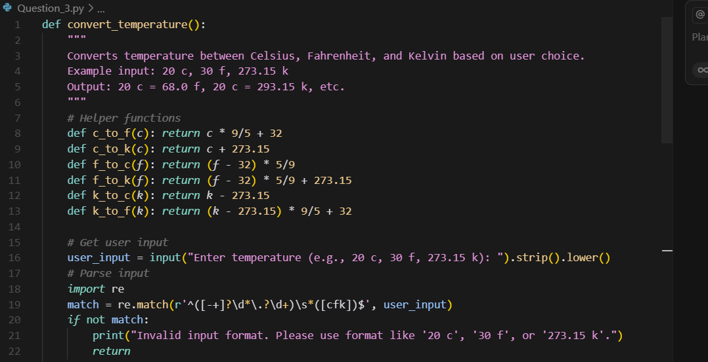
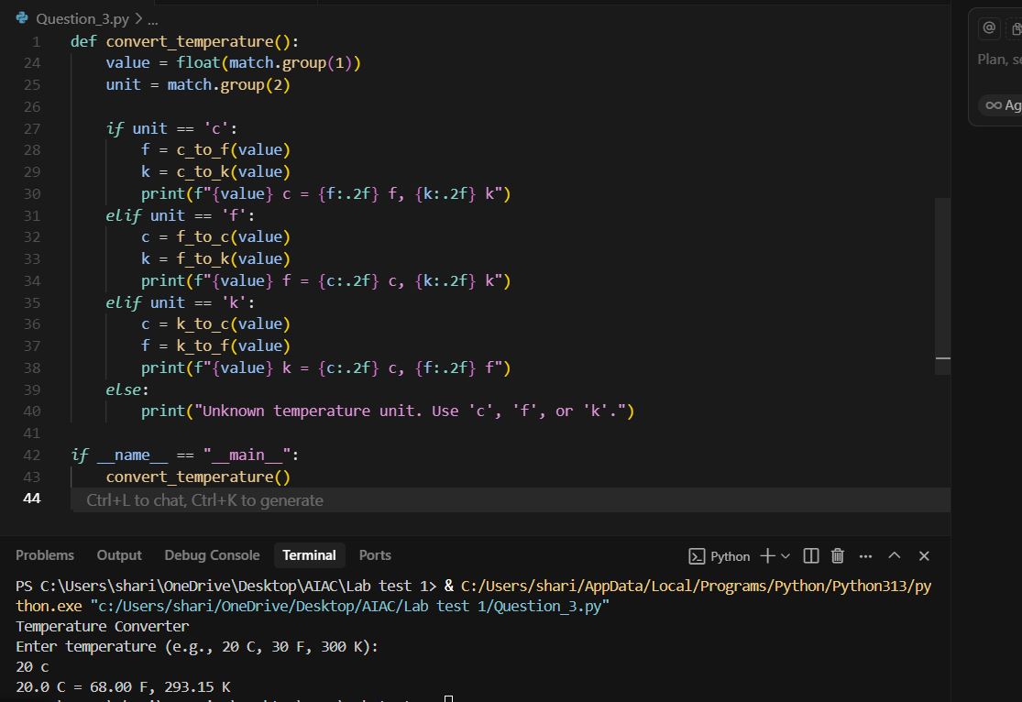4. Write a Python function to remove punctuation, convert to lowercase, and remove stop words from a given text. Use the Cursor AI tool. Use zero shot prompting
Prompt: Write a python program remove punctuation, convert to lowercase, and remove stop words from a given text and text as user input form
